Practices In The Kitchen:
- Dry wipe: pots, pans, dishware and work areas to remove all visible grease before washing equipment. Dispose the waste in trash.
- Use drain screens to capture food waste and dispose the waste in the trash.
- Post “No Grease” signs near all sinks or drains, including storm water drains.
- Recycle oil and grease.
- DO NOT POUR INTO FLOOR DRAINS OR STORM DRAINS
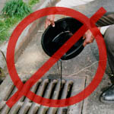

Prevent Releases To The Storm Drain:
Restaurants should pre-plan to have the right equipment, enough material and personnel to handle a spill or discharge.
It is important that the staff is trained in appropriate manner to handle the spills. Spills should be contained immediately through known and safe procedures.

To Report an Illicit Discharge Please Call
Borough of Coraopolis
412-264-3002

Storm Drains Are For Rainwater,
Not Wastewater!!

For more information about Borough of Coraopolis Storm Water Management Program, contact

Borough of Coraopolis
1012 5th Ave.
Coraopolis, PA 15108

Storm Water Pollution Control Practices for Food and Restaurant Industry

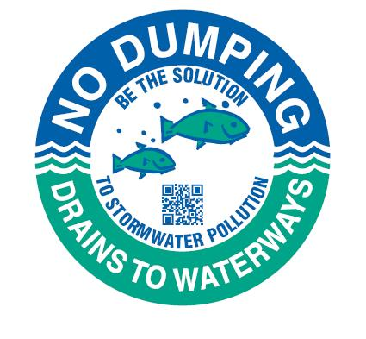

Borough of Coraopolis
Management Program
Storm Water Pollution:
Storm water runoff occurs when precipitation from rain flows over the ground. This runoff picks up chemicals, debris, dirt and other pollutants and flows into storm drains. The water from the storm drains directly discharge to surface waters without any treatment, resulting in the pollution of water we use for swimming, fishing and as a source of drinking water.
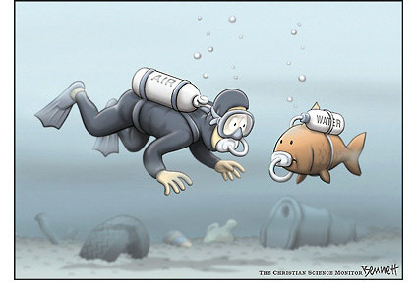

Problems:
The by-products of the food and restaurant industry can contaminate the natural waters if they enter the storm drain system. Restaurants can cause storm water pollution by:
- Dumping of waste in leaking dumpsters
- Washing outdoor spills into the storm drain system or
- Draining the wash water of equipment cleanup into storm drains
Oil and grease that enters natural waters through storm drains can clog fish gills and block oxygen from entering the water.

What Can You Do?
This brochure will explain the regulatory issues that should be followed when conducting cleaning activities at your food restaurant establishment to prevent storm water pollution.

General Cleaning Operations:
Follow these guidelines when cleaning your facility to prevent wash water and contaminants from entering the storm drains where it flows untreated to a water way.
- Clean floormats, filters and garbage cans in a mop sink or an area with a floor drain connected to a sanitary sewer.
- Wash greasy equipment such as vents in designated areas. Ensure that these designated areas are not connected to storm drains.
- Pour all wash water into a mop sink.
- Keep the dumpster areas clean and lids closed. Do not drain the liquid contents from the dumpster into a storm drain.
- Use suitable dry methods to clean any fluid spills; dispose properly
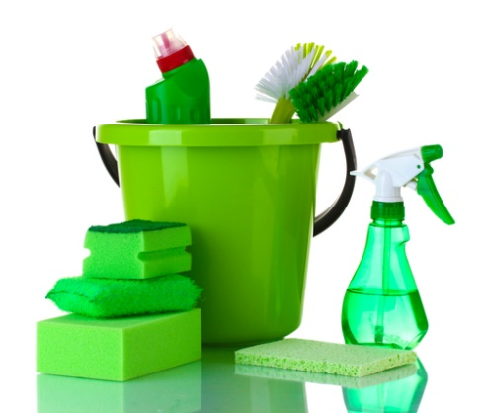

Minimizing Waste:
- Use non-toxic products for cleaning
- Use water-based products
- Use recycled containers
- Recycle waste whenever possible. Never dump oil and grease down the drain
- Keep recyclable wastes in separate containers. Some of the recyclable products are:
  - Food Waste
  - Paper and Cardboard
  - Glass Containers
  - Aluminum Containers
  - Tin Containers
  - Oil and Grease

